利用LSTM预测股票每日最高价
stock_predict_1.py
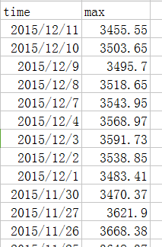
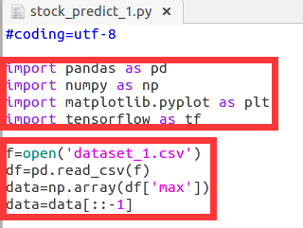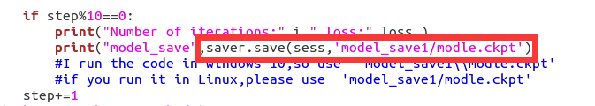
sun@ubuntu:~/sun/tensorflow_sun/stock_predict_with_LSTM-master$ python stock_predict_1.py
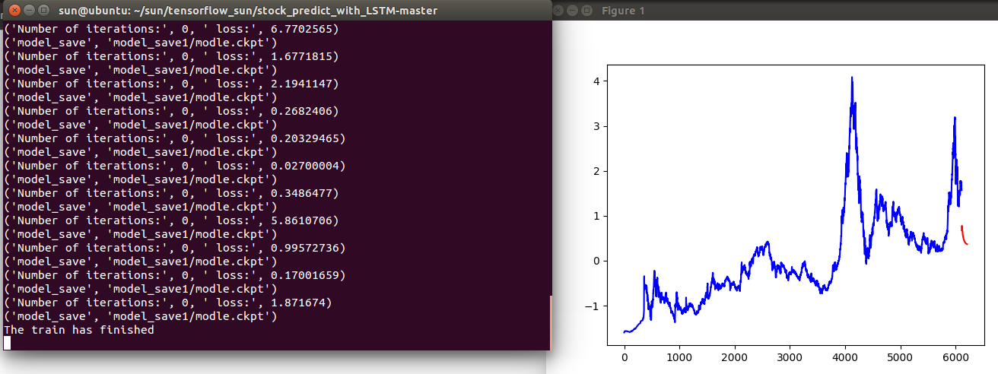

stock_predict_2.py

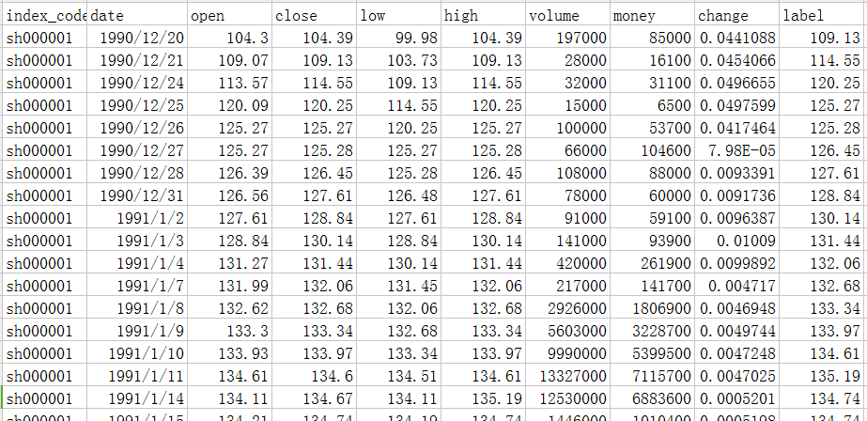
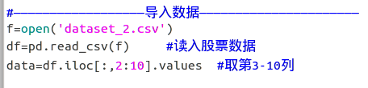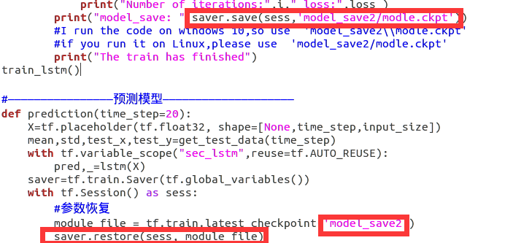
sun@ubuntu:~/sun/tensorflow_sun/stock_predict_with_LSTM-master$ python stock_predict_2.py
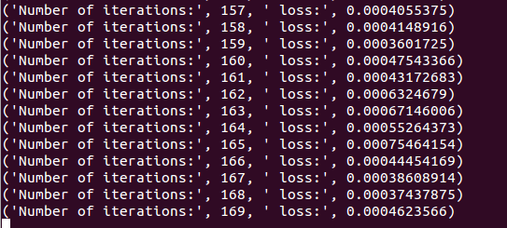
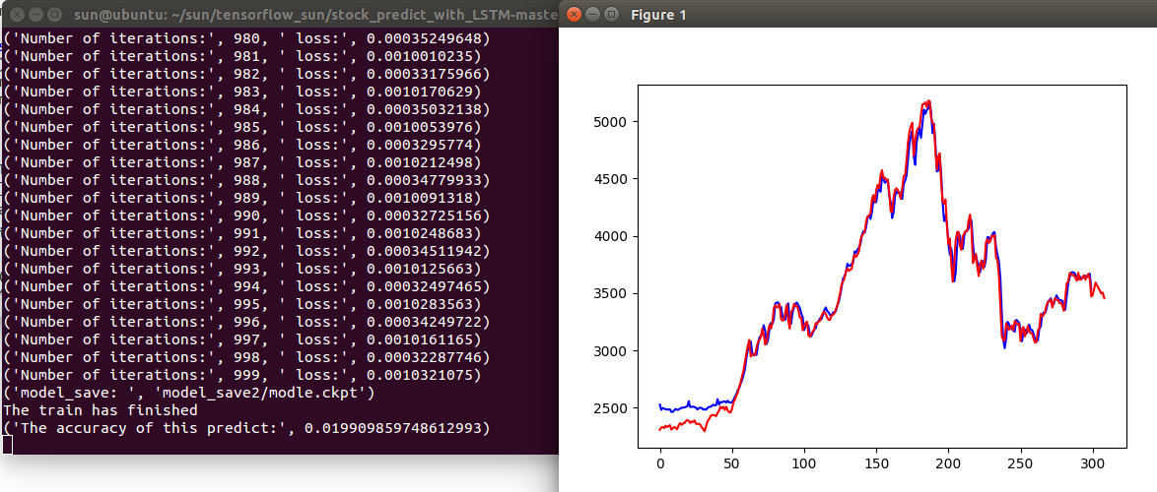

参考：
代码可直接运行：利用LSTM预测股票每日最高价
https://blog.csdn.net/songyunli1111/article/details/78513811
https://blog.csdn.net/mylove0414/article/details/55805974
https://blog.csdn.net/mylove0414/article/details/56969181

